Benny Lu

Implications

Privacy:

The information contained in the database will not be reveal to anyone unnecessary. Information as of sort will not be leaked out to anyone.

Functionality:

There aren’t many functions on the website as it is only a webpage. In the future when we connect the database to my website, the login and sign up will be function. Other function will be implemented in the future.

Accessibility:

This website can be access using a modern browser with a computer that has internet or data as tested with Google Chrome and Microsoft Edge.

Testing:

I’ve tested my website on Microsoft Edge and on Chrome, which both work perfectly fine. Every change I’ve made, I had tested to make sure it would work in at least 2 modern browsers.

Copyright:

https://www.socialmediaexaminer.com/copyright-fair-use-and-how-it-works-for-online-images/

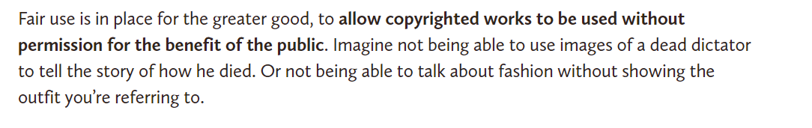

The images I use is for educational purposes, so therefore I have permission because if the images are to promote something. This is also is not for the benefit of the public but for school purposes.

All images' credits in my website are from [Riot Games](https://www.riotgames.com/en). The images have an alt to make if the images do not display it will provide alternate information for the screen reader not just a broken image.

Microsoft Edge:

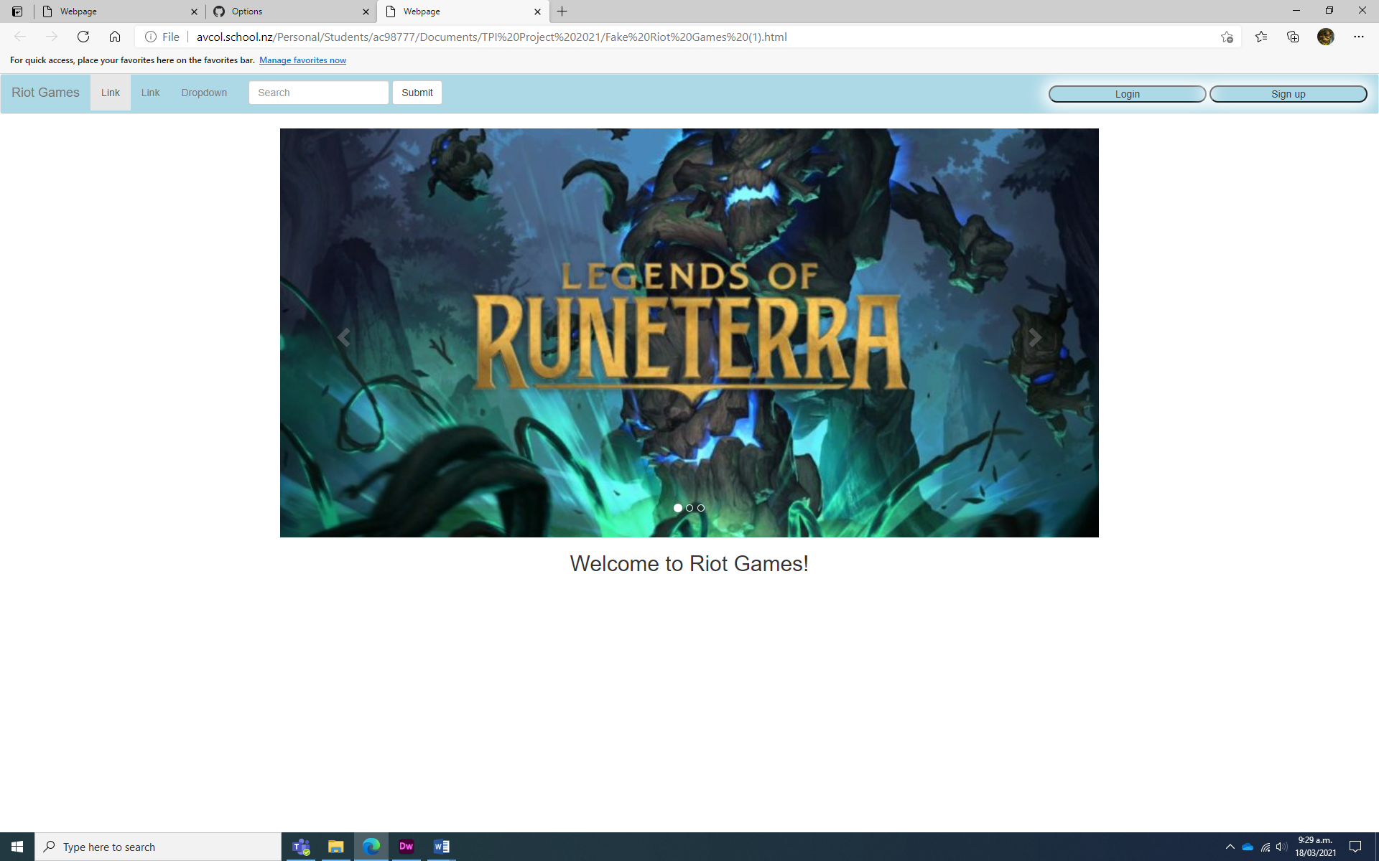

Chrome: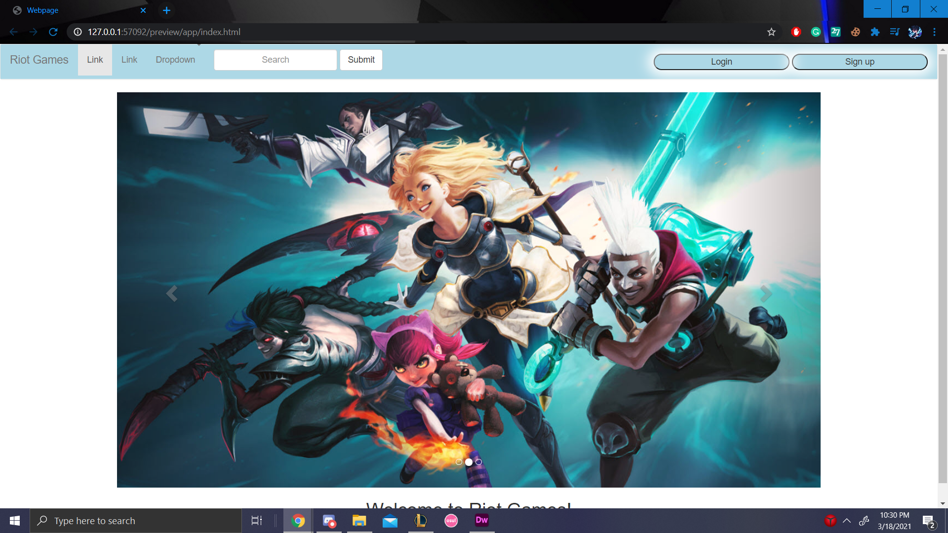

Feedback I’ve gotten:

To make my website more aesthetic, because it looks plain to the user. As a result, I’ve added a bit more colour to the pages. Therefore, I’ve added a bit more colour to all the pages.

The spelling in the Game.html page was wrong, which has been changed.

[GitHub](https://github.com/Benny-Lu/TPI-2021)

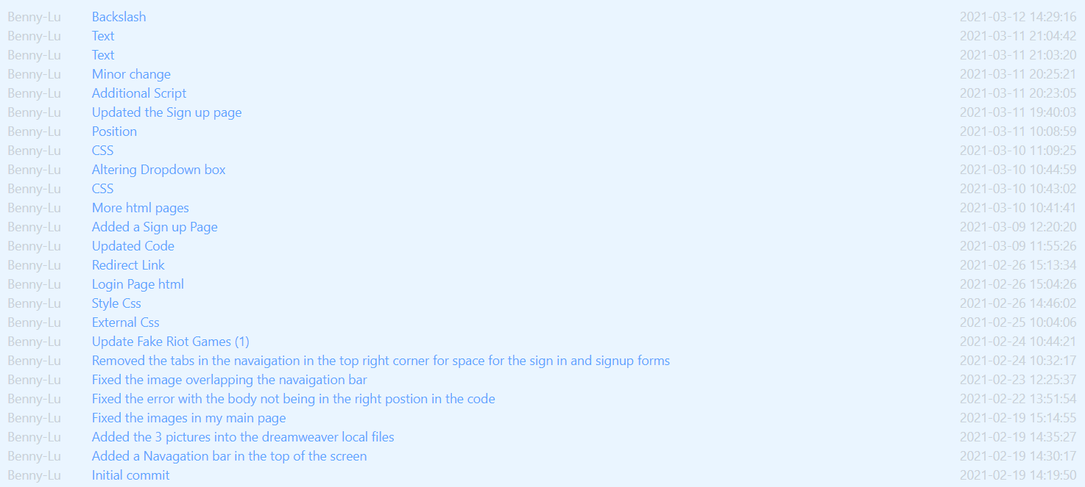

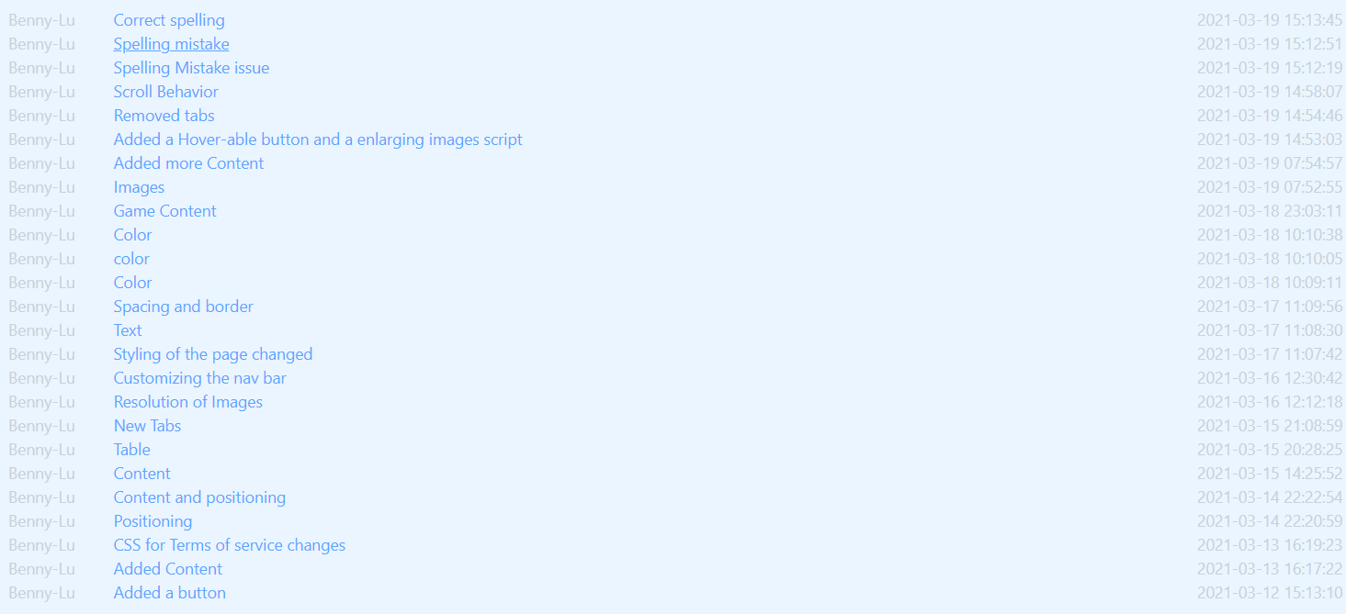



This is my commits in GitHub. This only shows the title of the commit not including the description. There are over 50 commits in these 3 pictures.